|  |
| --- |
|  |
| **Project Plan**  System Engineering**-**Company E |
| **COP** |
| Prepared for: |
| Anders Jacob Truelsen (Systematic) |
| By: Anders Torndahl, Christian Jensen, David Neergaard Rasmussen Marmoy, Michael Nygaard Pedersen, Peter Høgh Mikkelsen |
|  |

|  |  |
| --- | --- |
|  | |
| DOCUMENTTYPE | |
| Project: | $System Engineering**-**Company E |
| Revision: | $Revision: 2 $ $Date: 17/10/2010$ |
| Document: | Project Plan |
|  | |

Table of Contents

1 Introduction 1

2 Statement of work 2

2.1 Scope of Work 2

2.2 Location of Work 2

2.3 Period of Performance 2

2.4 Deliverables Schedule 2

2.5 Applicable Standards 2

3 Work Breakdown structure 3

4 Project schedule 4

5 References 5

# Introduction

This document contains the project plan for Company E which consist of the sections Statement of Work (SoW), Work Breakdown Structure (WBS) and the project schedule. The SoW describes the scope of the project in terms of work products, deliverables and location of work. WBS shows a rough product oriented view of the items in the system under design in different levels. The schedule is describes by using a Gannt chart to describe working periods, deliverables and milestones.

# Statement of work

## Scope of Work

The main task is to make a proposition for a extended Common Operations Picture (COP) including civilian scenarios such as fire department and police. Both static and dynamic information shall be provided by the COP. For a more detailed description see the case description[1].

Apart from that a proposal for at future dismounted COP must also be described, which must cost no more than 25.000 DKR.

The team must also be a subcontractor to Company A and thereby assist in their case from Terma.

The solution shall include the following documents:

* System Requirements Specification (SRS)
* Project Plan
* Detailed Design Description
* Interface Control Document
* Verification Matrix

## Location of Work

Team meetings will be held at the Engineering College of Aarhus. Work will both be performed by the project group at the Engineering College of Aarhus and individually at home by each team member.

## Period of Performance

The project period spans over the period from the 8th of September to 15th of October.

## Deliverables Schedule

In the development period a System Requirement Review must be conducted the 28th of September, where SRS and Project Plan must be delivered 72 hours before the review.

A Critical Design Review takes place the 11th of October and Detailed Design Description, Interface Control Document and Verification Matrix must be delivered 72 hours before the review.

## Applicable Standards

The solution must conform to the SitaWare infrastructure and any associated (military) standards.

# Work Breakdown structure

This chapter contains the WBS for the COP proposition done by Company E which can be seen on Figure 1.

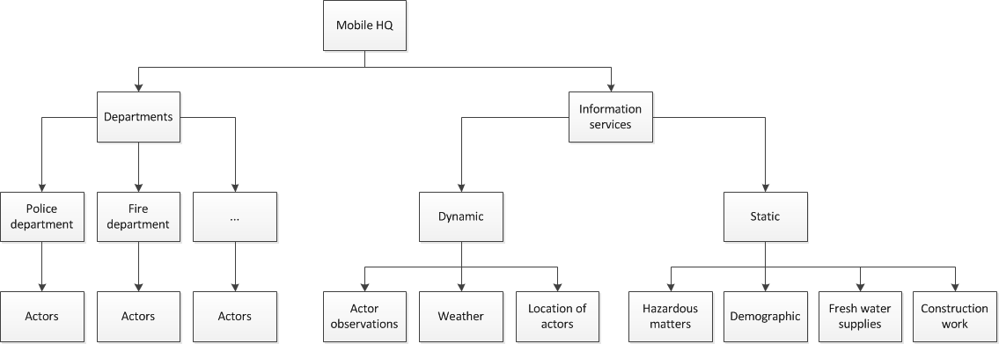

Figure : WBS for COP

# Project schedule

The project schedule is shown on Figure 2.

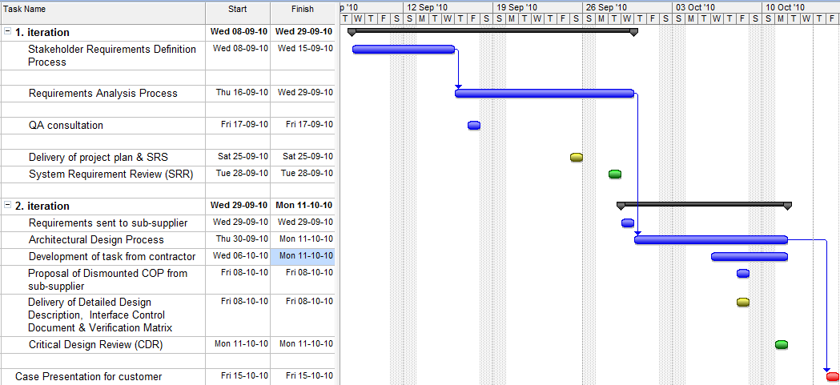

Figure : Project schedule

# References

1. Systematic, “Systematic Case”, rev 1.1, 2010